Table 1. Selection gradients I and I_{s} and or a) black coucals and b) white-browed coucals (x̄ = average value; σ² = variance; ENO = extra-nest offspring). Standardized Bateman gradients metrics based on relative (i.e., mean standardized) reproductive success and relative mating success. P (β > 0) indicates the posterior probability that the estimate is greater than zero.
 | N | Opportunity for selection |  |  |  | Opportunity for sexual selection |  |  |  | Bateman gradient  (Linear regression: absolute values) |  |  | Standardized Bateman gradient  (Linear regression by sex)
Black coucals
 | 299 | I | 95% Crl | x̄ | σ² | Is | 95% Crl | x̄ | σ² | βss | 95% Crl | P(β) > 0 | βss | 95% Crl | P(β) > 0
♀ | 120 | 0.65 | (0.44, 0.95) | 5.57 | 19.47 | 0.33 | (0.23, 0.44) | 1.91 | 1.19 | 2.99 | (2.63, 3.36) | 0.999 | 1.03 | (0.86, 1.20) | 0.999
no ENO ♂ | 144 | 0.20 | (0.15, 0.26) | 3.01 | 1.81 | 0.015 | (0.011, 0.019) | 1.02 | 0.02 | 1.67 | (-0.84, 4.26) | 0.907 | 0.54 | (-0.03, 1.13) | 0.968
ENO ♂ | 35 | 0.13 | (0.08, 0.23) | 5.29 | 5.97 | 0.13 | (0.07, 0.24) | 1.31 | 0.22 | 0.49 | (-1.08, 2.07) | 0.726 | 0.13 | (-0.23, 0.49) | 0.751
White-browed coucals
 | 162 | I |  | x̄ | σ² | Is |  | x̄ | σ² | βss | 95% Crl |  | βss | 95% Crl
♀ | 83 | 0.41 | (0.27, 0.63) | 4.71 | 8.87 | 0.04 | (0.02, 0.05) | 1.06 | 0.05 | 3.36 | (1.18, 5.58) | 0.998 | 0.75 | (0.24, 1.25) | 0.998
♂ | 79 | 0.38 | (0.25, 0.59) | 4.38 | 7.14 | 0 | - | 1 | 0 | - | - | - | - | - | -

Table 2. Estimates of sexual (xZ), remaining (rZ) and total selection (sZ) on female black coucal traits (Z), following the framework of Henshaw et al. (2018). Mating success (M) and reproductive success are mean-standardized, while body sizes (body mass, right tarsus length, tail length and scaled body mass index) and age are variance-standardized. Estimates and their 95% CrI are reported from Bayesian generalized linear models. P (β > 0) indicates the posterior probability that the estimate is greater than zero. Sample sizes differ from those in Table 1 due to limited data available on traits.

Parameter | - | Body mass | P(β) > 0 | Right tarsus length | P(β) > 0 | Tail length | P(β) > 0 | Scaled body mass index | P(β) > 0 | Age | P(β) > 0
Sample size |  | 67 |  | 67 |  | 65 |  | 68
Mating gradient on Z | βM Z | 0.00  (–0.13, 0.13) | 0.511 | –0.07  (–0.20, 0.06) | 0.144 | 0.01  (–0.13, 0.14) | 0.535 | 0.04  (–0.09, 0.17) | 0.757 | 0.04  (–0.11, 0.18) | 0.683
Selection gradient on Z (controlling for M) | βR Z = βR Z|M | –0.09  (–0.21, 0.04) | 0.089 | –0.06  (–0.18, 0.07) | 0.192 | –0.05  (–0.17, 0.08) | 0.229 | 0.03  (–0.15, 0.09) | 0.332 | 0.02  (–0.12, 0.15) | 0.585
Simple Bateman gradient | βss = βRM|∅ | 1.04  (0.81, 1.28) | 0.999 | 1.03  (0.80, 1.27) | 0.999 | 1.06  (0.84, 1.29) | 0.999 | 1.04  (0.81, 0.09) | 0.999 | 1.13  (0.87, 1.38) | 0.999
Partial Bateman gradient | βRM = βRM|Z | 1.04  (0.81, 1.27 | 0.999 | 1.02  (0.79, 1.23) | 0.999 | 1.06  (0.84, 1.29) | 0.999 | 1.04  (0.81, 1.29) | 0.999 | 1.12  (0.89, 1.37) | 0.999
Sexual selection | xZ = σ²Z βRM βM Z | 0.00  (–0.13, 0.14) | 0.518 | –0.07  (–0.20, 0.06) | 0.128 | 0.01  (–0.13, 0.14) | 0.531 | 0.05  (–0.09, 0.19) | 0.734 | 0.04  (-0.14, 0.21) | 0.680
Remaining selection | rZ = σ²Z βR Z | –0.09  (–0.22, 0.04) | 0.099 | –0.05  (–0.18, 0.07) | 0.170 | –0.04  –0.18, 0.09) | 0.204 | 0.03  (–0.15, 0.09) | 0.329 | 0.02  (-0.13, 0.17) | 0.600
Total selection (selection differential) | sZ = σZ R = xZ + rZ | 0.08  (–0.26, 0.11) | 0.189 | 0.02  (–0.17, 0.21) | 0.579 | 0.04  (–0.22, 0.13) | 0.325 | 0.02  (–0.17, 0.21) | 0.579 | 0.06  (-0.16, 0.29) | 0.693

Table 3. Estimates of sexual (xZ), remaining (rZ) and total selection (sZ) on male black coucal traits (Z), following the framework of Henshaw et al. (2018). Mating success (M) and reproductive success are mean-standardized, while body sizes (body mass, right tarsus length, tail length and scaled body mass index) and age are variance-standardized. Estimates and their 95% CrI are reported from Bayesian generalized linear models. These models included an interaction with male category (males with vs. without extra-nest offspring), allowing estimates to be extracted separately for each trait and male category according to a given parameter. P (β > 0) indicates the posterior probability that the estimate is greater than zero. Sample sizes differ from those in Table 1 due to limited data available on traits.

Parameter | - | Body mass |  |  |  | Right tarsus length |  |  |  | Tail length |  |  |  | Scaled body mass index |  |  |  | Age
Sample size |  | 69 |  | 23 |  | 70 |  | 24 |  | 69 |  | 24 |  | 69 |  | 23
Extra nest offspring |  | Without | P(β) >0 | With | P(β) >0 | Without | P(β) >0 | With | P(β) >0 | Without | P(β) >0 | With | P(β) >0 | Without | P(β) >0 | With | P(β) >0 | Without | P(β) >0 | With | P(β) >0
Mating gradient on Z | βM Z | 0.02  (–0.04, 0.08) | 0.737 | –0.05  (–0.16, 0.07) | 0.209 | –0.02  (–0.08, 0.04) | 0.240 | 0.04  (–0.08, 0.16) | 0.734 | 0.01  (–0.07, 0.05) | 0.348 | 0.20  (0.09, 0.32) | 0.999 | 0.04  (–0.02, 0.10) | 0.894 | –0.07  (–0.18, 0.03) | 0.088 | 0.09  (-0.02, 0.19) | 0.938 | -0.02  (-0.09, 0.05) | 0.297
Selection gradient on Z (controlling for M) | βR Z = βR Z|M | –0.04  (–0.14, 0.06) | 0.121 | –0.18  (–0.36, 0.02) | 0.035 | –0.04  (–0.15, 0.06) | 0.215 | 0.15  (–0.06, 0.35) | 0.921 | 0.04  (–0.07, 0.14) | 0.757 | –0.05  (–0.28, 0.18) | 0.340 | 0.00  (–0.10, 0.10) | 0.497 | –0.28  (–0.18, 0.03) | 0.001 | 0.16  (-0.02, 0.34) | 0.962 | -0.03  (-0.14, 0.09) | 0.333
Simple Bateman gradient | βss = βRM|∅ | 0.36  (–0.20, 0.92) | 0.895 | –0.05  (–0.50, 0.39) | 0.406 | 0.36  (–0.21, 0.94) | 0.894 | 0.01  (–0.44, 0.46) | 0.523 | 0.36  (–0.22, 0.94) | 0.889 | 0.01  (–0.43, 0.45) | 0.517 | 0.36  (–0.20, 0,92) | 0.892 | –0.06  (–0.49, 0.39) | 0.392 | 0.08  (-0.38, 0.52) | 0.631 | 0.34  (-0.23, 0.91) | 0.875
Partial Bateman gradient | βRM = βRM|Z | 0.39  (–0.19, 0.93) | 0.916 | –0.08  (–0.52, 0.36) | 0.366 | 0.35  (–0.24, 0.93) | 0.876 | 0.01  (–0.41, 0.42 | 0.520 | 0.37  (–0.22, 0.97) | 0.889 | –0.01  (–0.43, 0.45) | 0.479 | 0.43  (–0.14, 0.99) | 0.925 | –0.09  (–0.55, 0.32) | 0.358 | 0.05  (-0.39, 0.50) | 0.613 | 0.34  (-0.26, 0.89) | 0.872
Sexual selection | xZ = σ²Z βRM βM Z | 0.01  (–0.02, 0.05 | 0.675 | 0.00  (–0.03, 0.04) | 0.604 | –0.01  (–0.05, 0.02) | 0.318 | 0.00  (–0.04, 0.03) | 0.506 | 0.00  (–0.04, 0.02) | 0.353 | 0.00  (–0.10, 0.10) | 0.489 | –0.02  (–0.01, 0.06) | 0.837 | 0.01  (–0.03, 0.06) | 0.608 | 0.00  (-0.04, 0.06) | 0.591 | -0.01  (-0.05, 0.02) | 0.355
Remaining selection | rZ = σ²Z βR Z | –0.04  (–0.14, 0.07) | 0.230 | –0.18  (–0.37, 0.01) | 0.036 | –0.04  (–0.14, 0.06) | 0.206 | 0.15  (–0.06, 0.35) | 0.922 | 0.03  (–0.07, 0.14) | 0.745 | –0.05  (–0.27, 0.17) | 0.343 | 0.00  (–0.11, 0.10) | 0.528 | –0.28  (–0.46, –0.10) | 0.001 | 0.16  (-0.02, 0.34) | 0.964 | -0.03  (-0.14, 0.09) | 0.315
Total selection (selection differential) | sZ = σZ R = xZ + rZ | –0.04  (–0.15, 0.08) | 0.288 | –0.18  (–0.36, 0.02) | 0.040 | –0.05  (–0.15, 0.06) | 0.180 | 0.15  (–0.05, 0.35) | 0.920 | 0.03  (–0.08, 0.14) | 0.704 | –0.05  (–0.28, 0.19) | 0.339 | 0.02  (–0.09, 0.13) | 0.636 | –0.28  (–0.46, –0.09) | 0.001 | 0.17  (-0.02, 0.35) | 0.964 | -0.03  (-0.04, 0.08) | 0.278

Table 4. Estimates of sexual (xZ), remaining (rZ) and total selection (sZ) on female white-browed coucal traits (Z), following the framework of Henshaw et al. (2018). Mating success (M) and reproductive success are mean-standardized, while body (body mass, right tarsus length, tail length and scaled body mass index) are variance-standardized. Estimates and their 95% CrI are reported from Bayesian linear mixed models. P (β > 0) indicates the posterior probability that the estimate is greater than zero. Sample sizes differ from those in Table 1 due to limited data available on traits.
Parameter | - | Body mass | P(β) > 0 | Right tarsus length | P(β) > 0 | Tail length | P(β) > 0 | Scaled body mass index | P(β) > 0
Sample size |  | 40 |  | 40 |  | 40 |  | 40
Mating gradient on Z | βM Z | 0.11  (0.02, 0.20) | 0.994 | 0.04  (-0.06, 0.13) | 0.785 | –0.02  (–0.12, 0.08) | 0.318 | 0.08  (–0.01, 0.18) | 0.965
Selection gradient on Z (controlling for M) | βR Z = βR Z|M | –0.12  (–0.30, 0.06) | 0.093 | -0.13  (-0.30, 0.04) | 0.066 | 0.05  (-0.12, 0.23) | 0.736 | –0.02  (–0.20, 0.15) | 0.391
Simple Bateman gradient | βss = βRM|∅ | 0.49  (–0.05, 1.03) | 0.963 | 0.49  (-0.05, 1.02) | 0.962 | 0.5  (-0.04, 1.04) | 0.967 | 0.49  (–0.05, 1.04) | 0.963
Partial Bateman gradient | βRM = βRM|Z | 0.5  (–0.08, 1.06) | 0.954 | 0.48  (-0.03, 1.02) | 0.966 | 0.51  (-0.02, 1.04) | 0.965 | 0.52  (–0.06, 1.07) | 0.955
Sexual selection | xZ = σ²Z βRM βM Z | 0.06  (–0.01, 0.16) | 0.963 | 0.02  (-0.03, 0.08) | 0.758 | -0.01  (-0.07, 0.04) | 0.323 | 0.04  (––0.01, 0.13) | 0.927
Remaining selection | rZ = σ²Z βR Z | –0.12  (–0.29, 0.05) | 0.089 | -0.12  (-0.29, 0.03) | 0.061 | 0.05  (-0.12, 0.22) | 0.719 | –0.02  (–0.19, 0.15) | 0.392
Total selection (selection differential) | sZ = σZ R = xZ + rZ | –0.06  (–0.25, 0.13) | 0.260 | -0.11  (-0.28, 0.06) | 0.106 | 0.04  (-0.14, 0.21) | 0.661 | 0.02  (–0.17, 0.21) | 0.579

Table 5. Estimates selection gradient on male white-browed coucal traits (Z), following the framework of Henshaw et al. (2018). Reproductive success is mean-standardized, while body sizes (body mass, right tarsus length, tail length and scaled body mass index) are variance-standardized. Male mating is always one. Estimates and their 95% CrI are reported from Bayesian linear mixed models. P (β > 0) indicates the posterior probability that the estimate is greater than zero. Sample sizes differ from those in Table 1 due to limited data available on traits.
Parameter | - | Body mass | P(β) > 0 | Right tarsus length | P(β) > 0 | Tail length | P(β) > 0 | Scaled body mass index | P(β) > 0
Sample size | 54 |  |  | 54 |  | 56 |  | 56
Selection gradient on Z | βR Z | -0.01  (-0.14, 0.13) | 0.450 | -0.05  -0.19, 0.09) | 0.248 | 0.13  (0.00, 0.27) | 0.975 | 0.03  (-0.11, 0.17) | 0.655

Figure 1. Bateman gradients of female and male black coucals. (A) Absolute and (B) (mean standardized) reproductive success plotted against mating success for females (yellow), males without extra-nest offspring (dark blue), and males with extra-nest offspring (light blue). Jittered points represent individual data. Bold lines show fitted regression estimates derived from the posterior distributions of (A) a Poisson mixed-effects model and (B) Linear mixed-effects models fitted separately by sex and male category. Fine lines show their corresponding 95% CrI. Panels (C) and (D) show the estimated intercepts and slopes with 95% CrI from the models used in panels (A) and (B), respectively. Numerical estimates of slopes are reported in Table 1 and Supplementary Table S1.
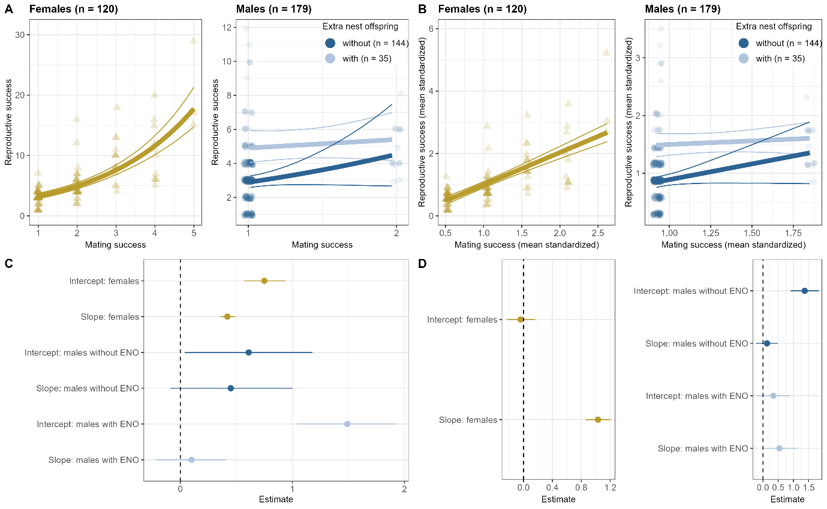

Figure 2. Bateman gradients of female white-browed coucals. (A) Absolute and (B) (mean standardized) reproductive success plotted against mating success for females (yellow). Jittered points represent individual data; male data are shown in blue. Bold lines show fitted regression estimates derived from the posterior distributions of a (A) generalized mixed-effects model with a Poisson error distribution and a (B) linear mixed-effects model. Fine lines represent the corresponding 95% CrI. Panels (C) and (D) show the estimated intercepts and slopes with 95% CrI from the models fitted in panels (A) and (B), respectively. Numerical estimates of slopes are reported in Table 1 and Supplementary Table S1.
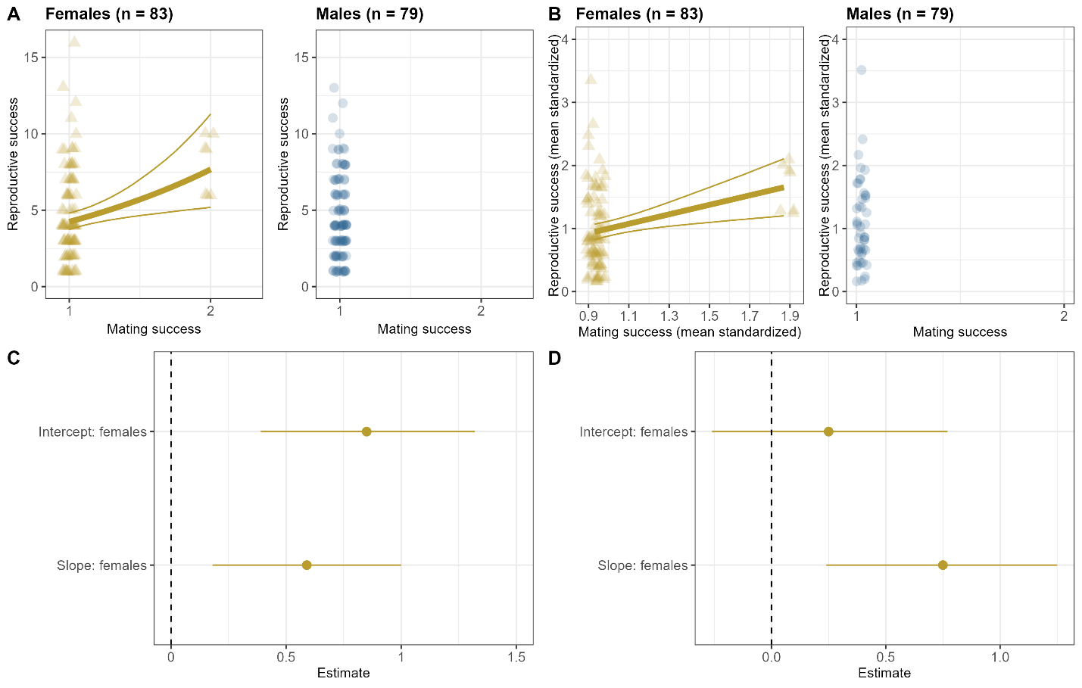

Figure 3. Selection gradients on traits in coucals, controlling for mating success (except in male white-browed coucals, which showed no variance in mating success). Reproductive success is mean-standardized, while morphological traits (body mass, right tarsus length, tail length and scaled body mass index) and age are variance-standardized. Panels (A–J) show results for black coucals, and panels (K–Q) for white-browed coucals. Bold lines show fitted regression estimates in yellow for females, light blue for males with extra-nest offspring, dark blue for males without extra-nest offspring and blue for male white-browed coucals. Estimates and corresponding 95% CrI; (shown as fine solid lines) are derived from Bayesian generalized linear models. Data displayed with jittering to show individual data points.
a) Black coucals
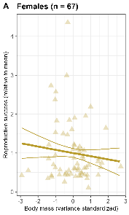 | 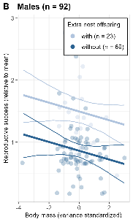 | 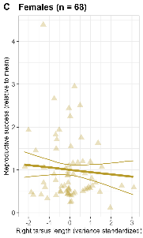 | 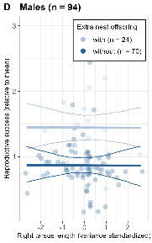 | 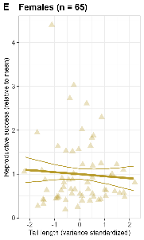 | 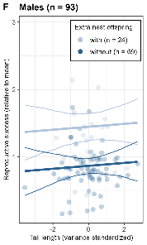 | 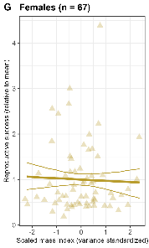 | 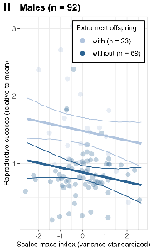 | 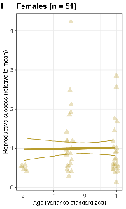 | 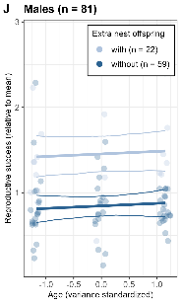
b) White-browed coucals
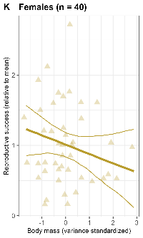 | 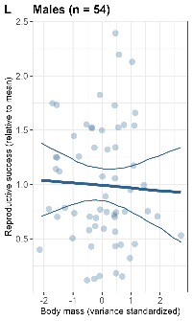 | 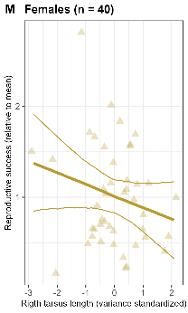 | 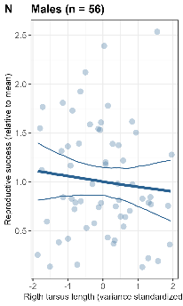 | 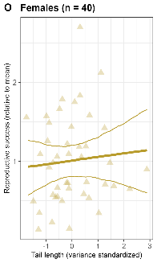 | 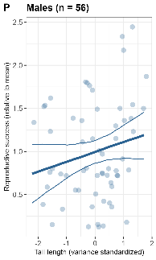 | 